Shopping Mission Interpreter — Failure Analysis
Option 1: Application Development · NLP Group Project
Idil Ure
Georgi Opnakov

1. Overview
This document looks at the main failure patterns we found in the Shopping Mission Interpreter. The system has two stages: Stage 1 turns a free text shopping request into a structured intent schema, and Stage 2 uses that schema to recommend products from the catalogue.
The analysis is based on the 50-example test set and the failure log generated from the evaluation run.
Dataset summary: 50 examples across 3 tiers (Easy: 16, Medium: 18, Hard: 16). The keyword baseline had at least one wrong field in 49/50 examples; the LLM had at least one wrong field in 37/50 examples. This does not mean every output was unusable. It means at least one schema field did not exactly match the gold label.

2. Evaluation Results

2.1 Keyword vs LLM — All Tiers
Field | Metric | Keyword | LLM | Delta
meal_occasion | Accuracy | 0.940 | 0.960 | +0.020
mission_type | Accuracy | 0.460 | 0.620 | +0.160
budget_sensitivity | Accuracy | 1.000 | 1.000 | 0.000
dietary_constraints | F1 | 0.857 | 0.957 | +0.100
preference_constraints | F1 | 0.772 | 0.786 | +0.014
product_categories | F1 | 0.514 | 0.618 | +0.104
risk_flags | F1 | 0.450 | 0.711 | +0.261
excluded_items | F1 | 0.750 | 1.000 | +0.250

The LLM improves almost all fields.The smaller gaps on meal occasion and budget make sense because those signals are usually stated directly.

2.2 Per-Tier Breakdown (Key Fields)
Field | System | Easy (16) | Medium (18) | Hard (16)
meal_occasion | KW / LLM | 0.88 / 0.94 | 1.00 / 1.00 | 0.94 / 0.94
mission_type | KW / LLM | 0.00 / 0.50 | 0.61 / 0.78 | 0.75 / 0.56
dietary_constraints | KW / LLM | 0.00 / 0.00 | 1.00 / 1.00 | 0.77 / 0.93
risk_flags | KW / LLM | 0.00 / 0.00 | 0.22 / 0.18 | 0.52 / 0.88
excluded_items | KW / LLM | 0.00 / 0.00 | 0.00 / 0.00 | 0.75 / 1.00
product_categories | KW / LLM | 0.95 / 0.98 | 0.20 / 0.41 | 0.29 / 0.50

The hard tier is where the LLM advantage is clearest. It handles negation and safety signals much better than the keyword baseline. The medium tier also shows one weakness: product category prediction becomes difficult when the request describes a goal rather than naming products.

3. Stage 1 Failures — Intent Parser

3.1 specific_ingredient Misclassification
The most repeated Stage 1 issue is mission_type. The LLM often over-interprets simple product lists by turning them into broader shopping missions, especially when the request includes words like “for breakfast” or “for dinner”.
Request | Gold mission_type | LLM predicted
I need cereal and coffee for breakfast | specific_ingredient | household_stock_up
Pasta and tomato sauce for dinner | specific_ingredient | convenience_meal
Two bottles of red wine | specific_ingredient | unclear
Some cheese and crackers | specific_ingredient | convenience_meal
I need diapers and baby formula | specific_ingredient | household_stock_up

Hypothesis: The boundary of specific_ingredient is not clear enough in the prompt. For us, this label means the shopper already knows exactly what they want. The model sometimes treats the same request as a broader stock-up or convenience mission. A small fix would be to add one or two few-shot examples, such as “Two bottles of red wine → specific_ingredient”.

3.2 Implicit Constraint Inference
Some requests contain a medical or dietary concept without naming the actual product constraint. This is where the keyword baseline is weakest, because it only sees surface words. The LLM does better on named conditions, but it still misses some logical implications.
Request | Expected output | Keyword | LLM
Birthday cake but my daughter is celiac | gluten_free + allergy_or_safety | missed | correct
I'm diabetic, need a breakfast that won't spike my sugar | low_sugar + allergy_or_safety | missed | correct
Protein but no meat and no soy | vegetarian + excluded soy | missed | missed vegetarian

Hypothesis: The LLM recognizes common named conditions such as celiac and diabetic because these are well-known associations. The harder case is “no meat”, where the system has to infer a dietary identity rather than match a disease name. This matters because missing a celiac or diabetic constraint is not just a scoring error; it could lead to unsafe product suggestions.

3.3 Negation That Must Remove a Product Category
Request: “Party drinks but nothing alcoholic, kids will be there”
Field | Gold | Keyword | LLM
excluded_items | ["alcohol"] | ["alcoholic"] partial | ["alcohol"]
product_categories | ["beverages"] | ["alcohol", "beverages"] wrong | ["beverages"] only
risk_flags | ["negation_present"] | correct | correct

Hypothesis: The keyword baseline applies negation and category rules separately. It can detect that a negation exists, but the alcohol category rule still fires. The LLM reads the whole sentence and removes the alcohol aisle. This is one of the easiest failures for a user to notice, because the request explicitly says “nothing alcoholic”.

3.4 Conflicting Goals and Schema Limitations
These examples are not just model errors. They also show a limitation in the schema. Some requests contain two goals or two people with different needs, but mission_type only allows one label.
Request | Gold mission_type | LLM predicted | LLM mission_summary
Something healthy but I still want it to feel indulgent | health_goal | unclear | healthy yet indulgent option
I want to lose weight but my husband wants comfort food | health_goal | unclear | balance between weight loss and comfort food
Dinner my vegetarian sister and meat-loving dad will both eat | party_hosting | unclear | dinner for both a vegetarian and a meat lover

Hypothesis: The LLM understands the tension in the free-text summary, but the closed mission_type field cannot represent two goals at once. This is a useful finding because it separates a model failure from a schema-design limitation. A future version should either allow multi-label mission_type or add a field for multi-person / conflicting-goal requests.

3.5 Over-Flagging Ambiguity
The LLM sometimes flags ambiguous_request even when a human could reasonably proceed. This happened several times in the medium tier and explains why the LLM risk_flags score is weak there.
Request | Gold risk_flags | LLM risk_flags
Something quick and easy for dinner tonight | none | ambiguous_request
Healthy lunch options for the office | none | ambiguous_request
I'm hosting friends this weekend, need party food | none | ambiguous_request
Easy no-cook lunch | none | ambiguous_request

Hypothesis: The prompt tells the model to flag missing information, but it does not define the difference between “not fully specified” and “not actionable”. Our gold labels use actionability: if a shopper or retailer could proceed without asking a follow-up question, we did not mark it as ambiguous. The model uses a stricter completeness standard.

3.6 Vague Category Inference
product_categories is the weakest field in the medium and hard tiers. When users describe a goal instead of naming products, both systems struggle to choose aisles.
Request | product_categories | LLM predicted
Healthy lunch options for the office | produce, ready_meals | empty
I'm hosting friends, need party food | snacks_sweets, alcohol, beverages | empty
Cheap filling meals for the week | pantry_staples, frozen, meat_seafood | empty
Stock up on basics for the month | pantry_staples, household_nonfood | too broad: many aisles

Hypothesis: Aisle prediction requires catalogue knowledge. The LLM can understand “healthy lunch”, but it does not know which product groups the retailer wants to map that phrase to. This is one reason the two-stage design makes sense: Stage 1 should interpret the mission, while Stage 2 can use actual product names for recommendation.

4. Stage 2 Failure — Product Recommender

4.1 Name-Based Reasoning Without Nutritional Grounding
Request: “I’m diabetic, need a filling breakfast that won’t spike my sugar”
Product recommended | Aisle | Score | Assessment
Coconut Almond Protein Chewy Bars | breakfast | 9/10 | reasonable if actually low sugar
Protein & Fiber Hot Oatmeal | breakfast | 8/10 | good fit
Organic Peanut Butter Chip Granola Bars | breakfast | 8/10 | risky: likely higher sugar
Post Selects Banana Nut Crunch Cereal | breakfast | 7/10 | risky: cereal may be high sugar

Observed failure: The model gives a high score to products whose names sound healthy, such as “organic”, “protein”, or “granola”. But without nutrition facts, it cannot check the sugar content. For a diabetic mission, this is the most important Stage 2 weakness.
Hypothesis: The Instacart product data contains product names and aisle labels, not ingredients, allergens, sugar, fibre, or calories. The recommender therefore reasons from naming cues. That is useful for many missions, but it is not reliable enough for health-sensitive requests.
Suggested fix: Link products to nutrition data, for example Open Food Facts or retailer product metadata. Until then, add simple filters for low_sugar missions that down-rank products containing words such as chip, sweetened, syrup, honey, candy, or crunch.
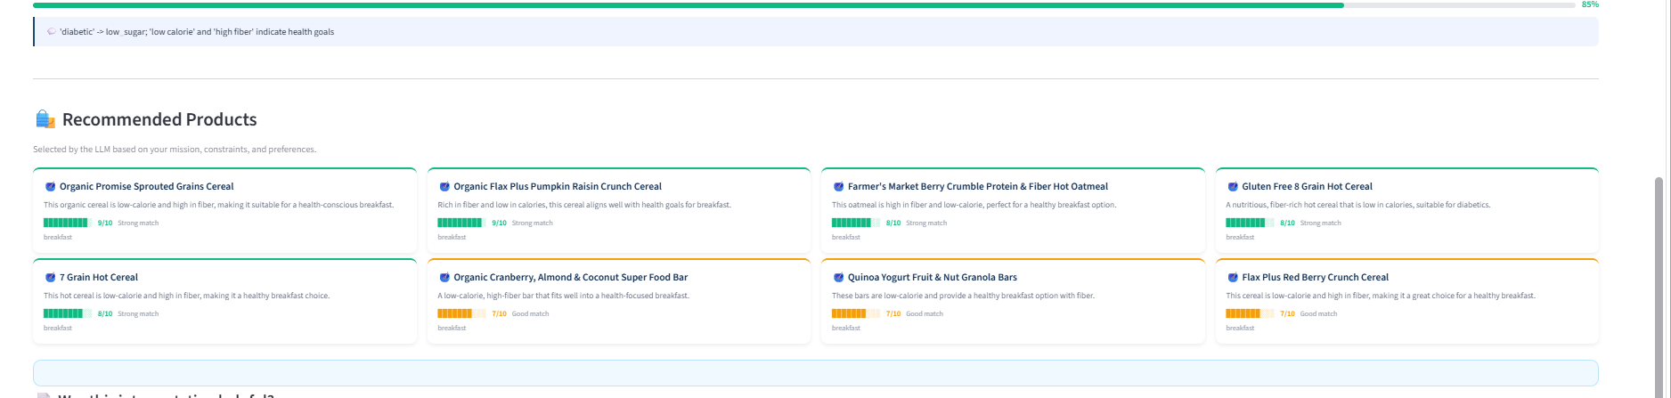 Fig. 1 — Cereals and granola scored highly for diabetic breakfast.
In fig 1 we see that the app is recommending non diabetic options.
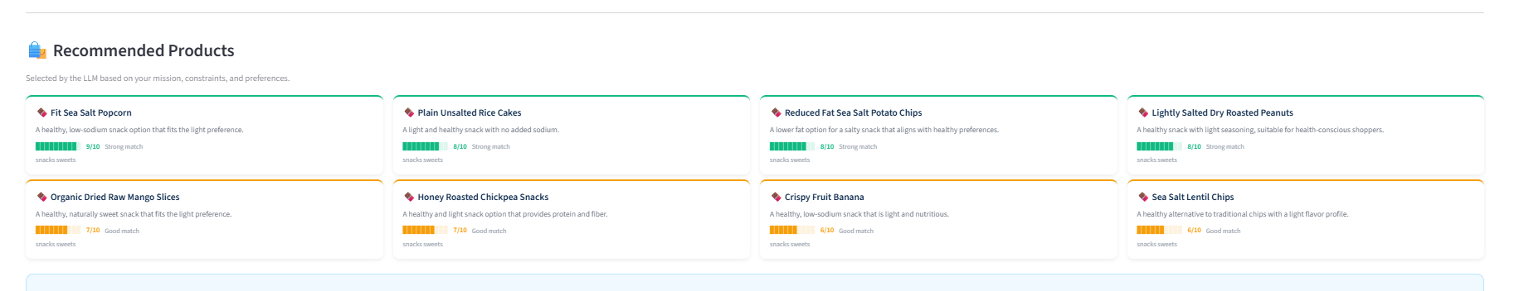
Fig. 5 — Healthy,salty low sodium options
In fig 2, we don’t have any data on the ingredients of the products. The LLM makes guess from the name of the product that it is low sodium however in reality it is high in sodium.

5. Cross-Case Summary
Type | Stage | System | Main field | Root cause | Possible fix
specific_ingredient confusion | Stage 1 | Both / LLM | mission_type | prompt boundary unclear | add few-shot examples
implicit constraint inference | Stage 1 | Keyword mainly | dietary_constraints | no semantic/world knowledge | safety synonym dictionary
negation + category | Stage 1 | Keyword | product_categories | rules do not interact | post-processing rule
conflicting goals | Stage 1 | Both | mission_type | single-label schema | multi-label mission_type
over-flagging ambiguity | Stage 1 | LLM | risk_flags | prompt definition too broad | define actionability
vague categories | Stage 1 | Both | product_categories | no catalogue context | move more logic to Stage 2
name-based product reasoning | Stage 2 | LLM recommender | product match | no nutrition data | add nutrition API

Overall, the LLM is most useful when language understanding matters: implicit constraints, negation, and risk flags. The keyword system is enough for simple product mentions and explicit budget words. The main weaknesses are not random. They come from three clear limits: the mission_type schema is sometimes too narrow, product category prediction needs catalogue knowledge, and the recommender needs nutrition data for health-sensitive requests.

6. Suggestions Before Final Submission
• Add 3-4 screenshots from the Streamlit app, especially one side-by-side comparison for Stage 1 and one product recommendation example for Stage 2.
• In the final report, do not say “49/50 keyword failures” without explaining that this means at least one field was wrong. Otherwise it sounds like the baseline completely failed.
• Add one sentence in the main technical report saying that product_categories should be treated as a secondary metric because it mixes intent parsing with catalogue mapping.
• For Stage 2, choose one more screenshot where the product name sounds healthy but the recommendation is questionable. This will make the nutritional-data limitation more convincing.
• If there is time, add a small rule-based fix after the LLM output: when excluded_items contains alcohol, remove alcohol from product_categories. This is an easy improvement to mention in future work or mitigation.

